Exercise Questions for Chapter 8
1. Perhaps the most popular nonlinear chemical engineering system is the nonisothermal CSTR in which the single, irreversible reaction 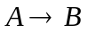is taking place. The model is given as:
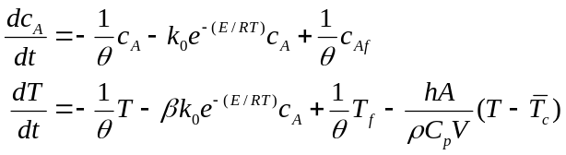
where: 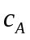is the concentration of reactant A in the reactor while T is reactor temperature, =V/F is the mean residence time in the reactor, k=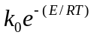 is the reaction rate constant, 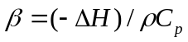 is a heat of reaction parameter, h as the coil heat transfer coefficient, A the total coil heat transfer area, and 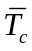 is the average temperature along the length of the coil. Linearize this set of equations around the steady states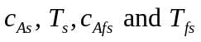.
2. A reactor used for the free-radical polymerization of methylmethacrylate (MMA) using azo-bis-isobutyronitrile (AIBN) as initiator, and toluene as solvent, is modeled by the following set of equations:
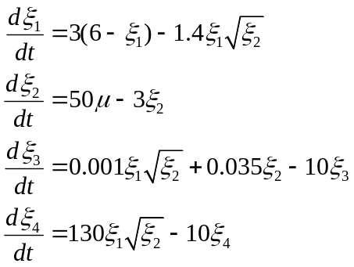
along with 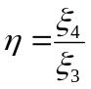. Here, 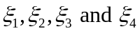 respectively represent the dimensionless monomer concentration, initiator concentration, bulk zeroth moment, and bulk first moment; is the number average molecular weight; and , is the volumetric flowrate of the initiator.
(a) Given an operating steady-state value, 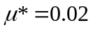 , obtain from the modeling equations the corresponding steady-state values for 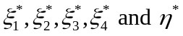. [Answer: ]
(b) Linearize the model equations around the steady-state values obtained in part (a), define the deviation variables 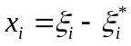 i = 1,2,3,4; 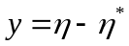; 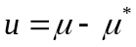; and obtain an approximate transfer function model relating y to u.

3. A mathematical model for the level of gasoline in a hemispherical storage tank is given as:
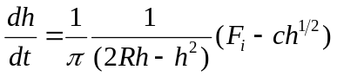
where R is the radius of hemispherical tank, F_{i} is the flowrate of gasoline into the storage tank.
(a) Linearize the original mathematical model, using a first-order Taylor series expansion; obtain an approximate transfer function model. Given a specific tank with parameters R = 2m, and c = 1.5m^{5/2}/min.), operating at initial steady-state conditions: F_{is} = 1.35 m³/min, h_{s}= 0.81m; [Answer: 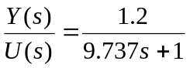]
(b) Convert the original nonlinear model equation to the first-order linear differential equation:
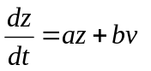
show explicitly what the variable z, v, and constants a and b are. [Answer: 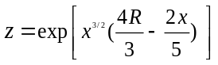; 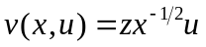]
(c) If instead it is desired to convert the model to the form
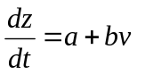
what nonlinear transformation will be required? [Answer: 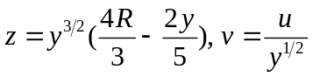]
4. A mathematical model for the isolated population dynamics of a typical generative biological system is given by:
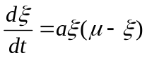
where
is the instantaneous population variable
a is a characteristic constant of the biological system
is the independent "source" term
a). For any given constant value 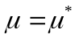, solve the model explicitly, given the initial population 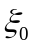at  and show the time behavior of is given by
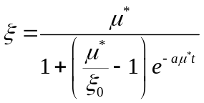
and hence establish that at steady state, as 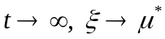. Also establish from the nonlinear model the steady-state relationship between the nontrivial equilibrium points 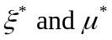. What does this indicate about the process steady-state gain?
(b) Linearize this model around an arbitrarily specified equilibrium point indicated by , define the deviation variables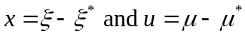, obtain an approximate transfer function relating x to u, and show that the steady-state gain indicated by this approximate transfer function is in fact entirely independent of the actual equilibrium point around which the model was linearized. What is the indicated apparent time constant? [Answer: 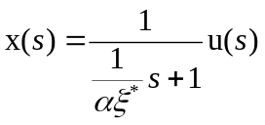]
5. For many chemical and biological processes, the steady-state gain changes when a process operating condition such as throughput changes. Consider a biomedical application where a drug flow rate is used to control blood pressure. The steady-state gain K_{p} varies with the manipulated variable u according to the relation,
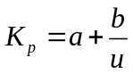
where u > 0 and a and b are constants that have been determined by fitting steady-state data. Suggest a modification for the standard PID controller to account for this variation in the process gain. Justify your answer. (In the above equation, u is not a deviation variable).

6. The product quality from a catalytic tubular reactor is controlled by the flow rate of the entering stream, utilizing composition measurements from a process gas chromatograph. The catalyst decays over time and once its overall activity drops below 50%, it must be recharged. Deactivation usually takes two to three months to occur. One measure of catalyst activity is the average of three temperature measurements that are used to estimate the peak temperature. Discuss how you would employ an adaptive control scheme to maintain product quality at acceptable levels. What transfer functions would need to be determined and why?

7. A second-order process is controlled by a PID controller. The desired closed-loop servo transfer function is
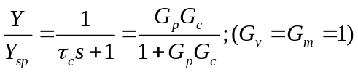
and the process model is
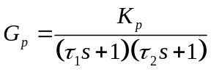
- Derive a control law that shows how to adjust K_{c}, 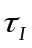, and 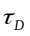 based on variations in K_{p}, , and 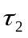 and the desired closed-loop time constant 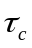.
- Suppose = 3, = 5, and K_{p} =1. Calculate values of K_{c}, and to achieve =1.5. Show how the response deteriorates for changes in the following model parameters when the controller remains unchanged: 1) K_{p} = 2; 2) K_{p} = 0.5; 3) = 10; 4) = 1;

8. The Ideal Gas Company has a process that requires an adaptive PI controller, but the company capital budget has been frozen. Mr. A has been given the job to develop a homegrown, cheap adaptive controller. It has been suggested that the closed-loop response after a disturbance can be studied to determine how to adjust K_{c} and incrementally up or down, using measures such as settling time, peak error, and decay ratio. Mr. A has proposed the following algorithm: If decay ratio > 0.25, reduce K_{c}. If decay ratio < 0.25, increase K_{c}. He is not sure how to adjust . Critique his rule for K_{c} and propose a rule for changing .

